MAJOR PROJECT

Topic: Azure Sentinel SIEM with Honeypot VM for Real-Time Cyber Attack Monitoring & Geolocation Visualization
Table of Contents
1. Abstract 3
2. Introduction 3
2.1 Overview of Cybersecurity Challenges 3
2.2 Role of SIEM in Cybersecurity 4
2.3 Purpose of the Project 4
2.4 Integration of Threat Intelligence 4
2.5 Significance of the Study 4
3. Background and Literature Review 5
3.1 Evolution of Cybersecurity Monitoring 5
3.2 Honeypots in Cybersecurity 5
3.3 Role of SIEM Technologies 5
3.4 RDP Brute Force Attacks 5
3.5 Geolocation-Based Threat Analysis 6
3.6 Summary of Literature 6
4. Project Objectives 6
4.1 Primary Objective 6
4.2 Specific Objectives 6
4.3 Expected Outcomes 7
5. System Architecture 7
5.1 Overview of System Design 8
5.2 Core Components 8
5.3 Data Flow Process 8
6. Methodology 9
6.1 Overview of Methodology 9
6.2 Azure Environment Setup 9
6.3 Virtual Machine Deployment (Honeypot Setup) 9
6.4 Firewall and Network Configuration 10
6.5 Log Collection and Monitoring 10
6.6 SIEM Configuration and Integration 10
6.7 Geolocation Data Enrichment 10
6.8 Custom Log Creation and Data Parsing 11
6.9 Data Visualization and Analysis 11
6.10 Summary of Methodology 11
7. Implementation 11
7.1 Overview of Implementation 12
7.2 Deployment of Azure Resources 12
7.3 Continuous Monitoring of the Virtual Machine 12
7.4 Log Collection and Integration 12
7.5 Configuration of SIEM Platform 13
7.6 Creation of Custom Logs 13
7.7 Data Extraction Using KQL 13
7.8 Visualization and Dashboard Creation 13
7.9 Summary of Implementation 14
8. Data Collection and Analysis 14
8.1 Overview of Data Collection 14
8.2 Collection of Failed Login Events 14
8.3 Data Enrichment and Processing 15
8.4 Analysis of Attack Patterns 15
8.5 Summary of Data Analysis 16
9. Results and Findings 16
9.1 Overview of Observed Results 16
9.2 Detection of RDP Brute Force Attacks 16
9.3 Geographical Distribution of Attacks 17
9.4 Visualization of Global Attack Patterns 17
9.5 Continuous Attack Behaviour 18
9.6 Summary of Findings 18
10. Discussion 18
10.1 Effectiveness of SIEM-Based Monitoring 18
10.2 Insights from Geolocation Integration 19
10.3 Analysis of Attack Behaviour 19
10.4 Practical Implications 19
11. Challenges and Limitations 19
11.1 API Rate Limitations 19
11.2 Complexity in Log Parsing 20
11.3 Azure Resource Configuration Issues 20
11.4 Time Constraints 20
11.5 Summary of Limitations 20
12. Recommendations and Future Work 20
12.1 Implementation of Automated Response Mechanisms 20
12.2 Integration of Machine Learning Techniques 21
12.3 Deployment of Multiple Honeypots 21
12.4 Enhancement of Visualization Dashboards 21
12.5 Future Scope 21
13. Conclusion 21
14. References 22

1. Abstract
This project presents the design and implementation of a cloud-based Security Information and Event Management (SIEM) system using Microsoft Azure Sentinel integrated with a honeypot virtual machine (VM). The primary objective is to capture, analyse, and visualize real-time cyberattack attempts, specifically Remote Desktop Protocol (RDP) brute force attacks, originating from across the globe. A deliberately exposed Windows-based virtual machine was deployed to act as a honeypot, attracting malicious login attempts.
The system collects security logs from the VM using Azure Log Analytics Workspace (LAW). A custom PowerShell script was developed to extract attacker IP addresses from failed login events and enrich them with geolocation data using an external API. This enriched data was then ingested into Azure Sentinel, where advanced queries and visualizations were used to monitor attack patterns.
The results demonstrate that within a short time, the honeypot attracted numerous attack attempts from multiple countries, including China, Russia, and the Philippines. The visualization of these attacks on a world map provided clear insights into global threat distribution. This project highlights the effectiveness of SIEM tools in cybersecurity monitoring and demonstrates practical skills in cloud security, log analysis, and threat intelligence.

2. Introduction

2.1 Overview of Cybersecurity Challenges
With the increasing reliance on cloud computing and internet-based services, cybersecurity threats have become significantly more frequent and sophisticated. Modern organizations depend heavily on interconnected systems, which makes them vulnerable to various cyberattacks. Among these, unauthorized access attempts through exposed services such as Remote Desktop Protocol (RDP) are particularly common. Attackers often use brute force techniques to gain access by repeatedly attempting different username and password combinations. Therefore, continuous monitoring and analysis of such threats are essential for maintaining system security and preventing potential breaches.

2.2 Role of SIEM in Cybersecurity
Security Information and Event Management (SIEM) systems play a crucial role in modern cybersecurity operations. These systems are designed to collect, analyse, and correlate log data from multiple sources within an IT environment. By providing centralized visibility, SIEM solutions help security analysts detect suspicious activities, respond to incidents, and maintain compliance with security standards. Microsoft Azure Sentinel is a cloud-based SIEM solution that offers advanced threat detection, real-time monitoring, and intelligent security analytics. Its scalability and integration capabilities make it suitable for both small and large-scale security operations.

2.3 Purpose of the Project
This project focuses on building a practical cybersecurity monitoring system using Azure Sentinel. A virtual machine configured as a honeypot was intentionally exposed to the internet to attract malicious activity. By capturing and analysing failed login attempts, the system provides valuable insights into attacker behaviour and attack patterns. The use of a honeypot allows for controlled observation of real-world cyber threats without compromising critical systems.

2.4 Integration of Threat Intelligence
To enhance the effectiveness of the monitoring system, geolocation enrichment was implemented using a custom PowerShell script and an external API. This process enables the identification of the geographical origin of attackers based on their IP addresses. The enriched data is then visualized on a global map, providing a clear representation of attack distribution. This integration of threat intelligence improves situational awareness and supports better decision-making in cybersecurity operations.

2.5 Significance of the Study
The project not only demonstrates the technical implementation of a SIEM-based monitoring system but also emphasizes the importance of proactive security measures. Real-time monitoring and visualization of cyber threats enable organizations to respond quickly and effectively. This study highlights how cloud-based security solutions can be leveraged to strengthen defence mechanisms and improve overall cybersecurity posture.

3. Background and Literature Review

3.1 Evolution of Cybersecurity Monitoring
Cybersecurity research has evolved significantly with the rapid growth of digital infrastructure and cloud computing. Traditional security mechanisms such as firewalls and antivirus systems are no longer sufficient to combat advanced and persistent cyber threats. As a result, modern approaches focus on continuous monitoring, threat detection, and incident response. Intrusion Detection Systems (IDS) and Security Information and Event Management (SIEM) solutions have become essential components in identifying and mitigating cyber risks. These systems provide real-time visibility into network activities and help organizations respond proactively to potential attacks.

3.2 Honeypots in Cybersecurity
Honeypots are widely used as an effective defensive strategy in cybersecurity. A honeypot is a deliberately vulnerable system designed to attract attackers and study their behaviour in a controlled environment. By simulating real systems, honeypots allow researchers and security professionals to observe attack patterns, tools, and techniques without risking critical infrastructure. The data collected from honeypots is valuable for understanding emerging threats and improving security mechanisms. In recent studies, honeypots have been used to analyse brute force attacks, malware distribution, and unauthorized access attempts.

3.3 Role of SIEM Technologies
Security Information and Event Management (SIEM) systems play a crucial role in modern cybersecurity frameworks. These systems collect and aggregate log data from various sources, including servers, applications, and network devices. Advanced SIEM solutions, such as Microsoft Azure Sentinel, provide powerful analytics, automation, and threat intelligence capabilities. They utilize machine learning and behavioural analysis to detect anomalies and identify potential security incidents. Research indicates that integrating SIEM systems with real-time monitoring significantly enhances an organization’s ability to detect and respond to cyber threats efficiently.

3.4 RDP Brute Force Attacks
Remote Desktop Protocol (RDP) brute force attacks are among the most common attack vectors in modern cybersecurity. In such attacks, malicious actors attempt to gain unauthorized access by systematically trying different username and password combinations. These attacks are often automated and can generate a large number of failed logins attempts within a short period. Monitoring RDP activity is critical, as successful breaches can lead to data theft, ransomware deployment, and system compromise. Studies have shown that exposed RDP ports are a major target for attackers worldwide, making them an ideal focus for honeypot-based research.

3.5 Geolocation-Based Threat Analysis
Geolocation-based threat analysis is an important technique used in cybersecurity to enhance situational awareness. By mapping IP addresses to geographical locations, security analysts can identify the origin of cyberattacks and detect regional patterns. This approach helps organizations prioritize defensive strategies and allocate resources effectively. Integrating geolocation data with SIEM systems allows for advanced visualization, such as global attack maps, which provide intuitive insights into threat distribution. Previous research highlights that combining geolocation intelligence with log analysis improves threat detection and response capabilities.

3.6 Summary of Literature
This project builds upon the concepts of honeypot deployment, SIEM-based monitoring, and geolocation analysis to create a unified cybersecurity solution. By integrating these technologies, the system provides a comprehensive approach to capturing, analysing, and visualizing real-world cyber threats. The literature supports the effectiveness of such integrated systems in improving threat detection, understanding attacker behaviour, and strengthening overall cybersecurity posture.

4. Project Objectives

4.1 Primary Objective
The primary objective of this project is to design and implement a cloud-based cybersecurity monitoring system using Microsoft Azure Sentinel integrated with a honeypot virtual machine. The system aims to simulate a real-world environment where cyber threats can be captured, analysed, and visualized effectively.

4.2 Specific Objectives
The project focuses on several specific objectives to achieve its overall goal:
- To design and deploy a honeypot virtual machine in the Microsoft Azure environment, intentionally exposed to attract malicious activities.
- To capture real-time Remote Desktop Protocol (RDP) brute force attack attempts by monitoring failed login events.
- To collect, store, and analyse security logs using Azure Sentinel and Log Analytics Workspace for centralized monitoring.
- To develop and implement a custom PowerShell script for enriching log data with geolocation information using an external API.
- To visualize global, cyberattack patterns through an interactive world map, enabling better understanding of attacker distribution.

4.3 Expected Outcomes
The expected outcome of this project is to demonstrate the practical application of SIEM tools in detecting and analysing cyber threats. It also aims to provide insights into real-world attack behaviour and highlight the importance of proactive cybersecurity monitoring and threat intelligence integration.

5. System Architecture

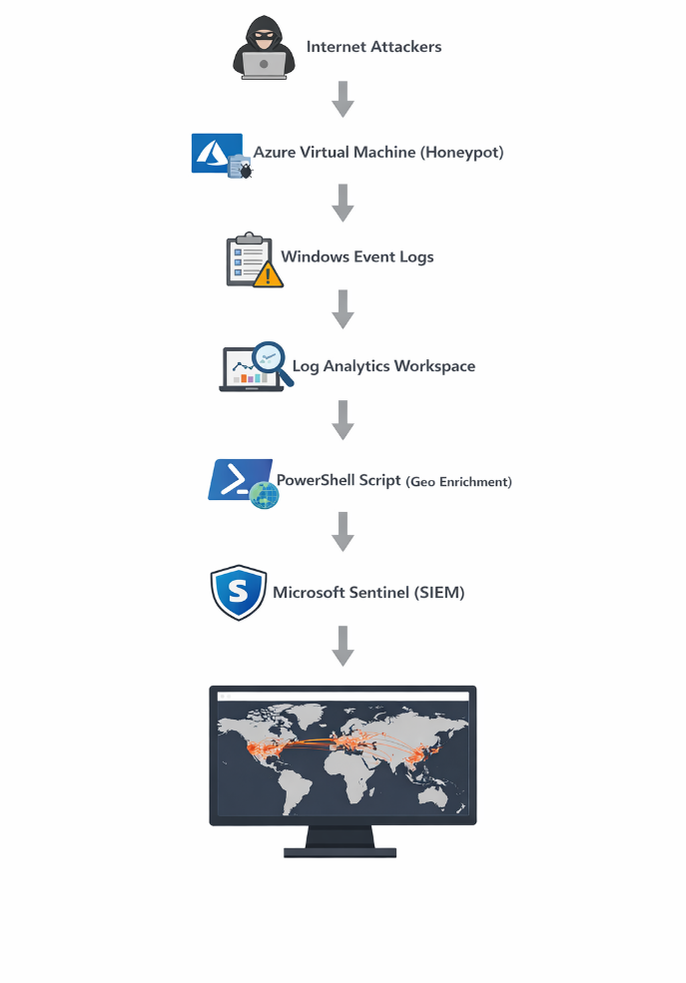
Figure 1: System Architecture of Azure Sentinel Honeypot SIEM

5.1 Overview of System Design
The system architecture for this project is designed to provide a comprehensive and scalable cybersecurity monitoring solution using cloud-based technologies. It integrates multiple components that work together to capture, process, analyse, and visualize cyberattack data in real time. The architecture leverages Microsoft Azure services to ensure reliability, flexibility, and efficient data handling.

5.2 Core Components
The system consists of several key components, each performing a specific function:
- Azure Virtual Machine (Honeypot):
A Windows-based virtual machine is deployed and intentionally exposed to the internet to attract malicious login attempts. It acts as the primary data source for capturing cyberattack activity.
- Windows Event Logs:
The virtual machine generates security logs, particularly failed login events (Event ID 4672), which are crucial for identifying brute force attacks.
- Log Analytics Workspace (LAW):
This component collects and stores log data from the virtual machine. It acts as a centralized repository for further analysis.
- PowerShell Script for Data Enrichment:
A custom script extracts attacker IP addresses from the logs and enriches them with geolocation information such as country, latitude, and longitude using an external API.
- Microsoft Azure Sentinel:
Azure Sentinel serves as the SIEM solution, enabling advanced log analysis, threat detection, and visualization through Kusto Query Language (KQL).
- Visualization Dashboard:
A dashboard is created within Azure Sentinel to display attack data on a world map, providing intuitive insights into global attack patterns.

5.3 Data Flow Process
The data flow begins with the honeypot virtual machine, where cyberattack attempts are recorded in Windows Event Logs. These logs are transmitted to the Log Analytics Workspace for storage and processing. The PowerShell script then enriches the data by adding geolocation details. Finally, Azure Sentinel analyses the enriched data and presents it through interactive visualizations, enabling effective monitoring and analysis of cyber threats.

6. Methodology

6.1 Overview of Methodology
The methodology adopted in this project follows a systematic approach to design, implement, and evaluate a cloud-based cybersecurity monitoring system. The process involves setting up a honeypot environment, collecting real-time attack data, enriching the data with geolocation information, and analysing it using a SIEM platform. Each step is carefully executed to ensure accurate data collection and meaningful insights into cyberattack patterns.

6.2 Azure Environment Setup
The first step in the methodology involved setting up the cloud environment using Microsoft Azure. An Azure account was created, and a subscription was activated to access cloud services. A resource group was then configured to organize all project-related resources in a structured manner. This approach ensures better management, scalability, and ease of deployment.
The cloud-based setup provides flexibility and allows the system to operate continuously without the need for physical infrastructure. Additionally, Azure services offer built-in security features and integration capabilities, making them suitable for implementing a SIEM-based monitoring system.

6.3 Virtual Machine Deployment (Honeypot Setup)
A Windows-based virtual machine (VM) was deployed within the Azure environment to act as a honeypot. The VM was configured with Remote Desktop Protocol (RDP) access enabled, allowing remote login attempts. To increase the likelihood of attracting attackers, simple and weak credentials were intentionally used.
The VM was assigned a public IP address, making it accessible over the internet. This exposure is essential for simulating a real-world vulnerable system. The honeypot acts as the primary source of data, capturing malicious login attempts and providing insights into attacker behaviour.

6.4 Firewall and Network Configuration
To ensure that the honeypot could receive attack traffic, the Network Security Group (NSG) associated with the virtual machine was configured to allow inbound traffic on port 3389, which is used for RDP connections. The rule was set to allow traffic from any source, effectively exposing the VM to the global internet.
Additionally, the Windows Defender Firewall on the VM was disabled to maximize visibility of incoming connections and ensure that no potential attack data was blocked. While this configuration introduces security risks, it is necessary for the purpose of this controlled experiment.

6.5 Log Collection and Monitoring
Once the VM was operational, log collection was enabled to monitor system activities. Windows Event Viewer was used to capture security logs, specifically focusing on failed login attempts identified by Event ID 4672. These logs contain critical information such as the source IP address, timestamp, and login details.
To centralize log management, the virtual machine was connected to a Log Analytics Workspace (LAW). The LAW collects and stores log data from the VM, enabling further analysis and integration with other Azure services. This centralized logging approach is essential for efficient monitoring and data processing.

6.6 SIEM Configuration and Integration
The next step involved configuring the SIEM solution using Microsoft Azure Sentinel. Azure Sentinel was connected to the Log Analytics Workspace, allowing it to access and analyse the collected log data.
Azure Sentinel provides advanced capabilities such as threat detection, log correlation, and real-time monitoring. Using Kusto Query Language (KQL), custom queries were created to filter and analyse failed login attempts. This enabled the identification of attack patterns and the extraction of relevant data for further processing.

6.7 Geolocation Data Enrichment
To enhance the analysis, a custom PowerShell script was developed to enrich the collected log data with geolocation information. The script extracts attacker IP addresses from the security logs and sends them to an external geolocation API.
The API returns details such as the country name, latitude, and longitude associated with each IP address. This enriched data is then stored in a custom log file, which is uploaded to the Log Analytics Workspace. This process adds valuable context to the raw log data, making it easier to understand the origin of attacks.

6.8 Custom Log Creation and Data Parsing
After generating the enriched log file, a custom log was created in the Log Analytics Workspace to ingest this data. The raw log data was then parsed using Kusto Query Language (KQL) to extract structured fields such as IP address, country, latitude, and longitude.
This step is critical for enabling accurate analysis and visualization. Proper data parsing ensures that the information can be used effectively in queries and dashboards.

6.9 Data Visualization and Analysis
The final step in the methodology involved visualizing the processed data using Azure Sentinel. A workbook was created to display the geolocation data on a world map. The map uses latitude and longitude coordinates to plot attack locations, with markers indicating the frequency of attacks from different regions.
This visualization provides a clear and intuitive representation of global cyberattack patterns. It allows for easy identification of high-risk regions and helps in understanding the distribution of attack sources.

6.10 Summary of Methodology
The methodology integrates cloud infrastructure, log management, scripting, and data visualization into a unified system. By combining these elements, the project successfully demonstrates how real-time cyber threats can be captured, enriched, and analysed using modern SIEM tools. This structured approach ensures accuracy, scalability, and effectiveness in cybersecurity monitoring.

7. Implementation
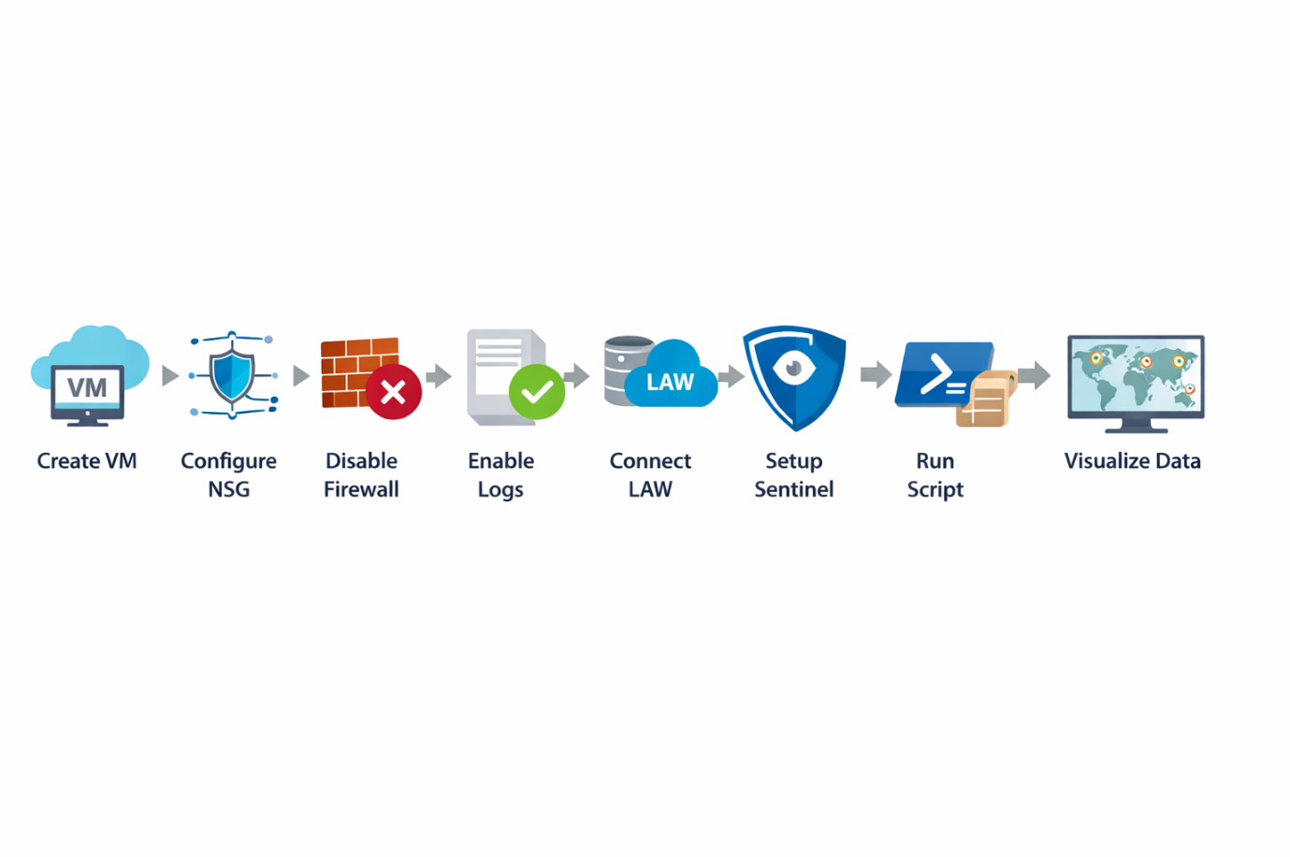Figure 2: Implementation Workflow

7.1 Overview of Implementation
The implementation phase of this project involved the practical deployment and configuration of all system components within the Microsoft Azure environment. This phase translated the planned architecture and methodology into a working cybersecurity monitoring system. Each component was configured step by step to ensure seamless data flow, accurate log collection, and effective visualization of cyberattack activities.

7.2 Deployment of Azure Resources
The first step in the implementation process was the creation and configuration of Azure resources. A resource group was established to manage all components of the project efficiently. Within this resource group, a Windows-based virtual machine was deployed and configured to act as a honeypot.
The virtual machine was assigned a public IP address and configured to allow Remote Desktop Protocol (RDP) access. Network Security Group (NSG) rules were modified to allow inbound traffic on port 3389 from any source. This intentional exposure enabled the VM to receive unauthorized login attempts from external attackers.

7.3 Continuous Monitoring of the Virtual Machine
Once the virtual machine was operational, continuous monitoring was implemented to track all incoming activities. The system was left running for an extended period to capture real-time attack attempts. During this time, multiple unauthorized login attempts were observed, confirming that the honeypot was successfully attracting malicious traffic.
The Windows Event Viewer on the VM was used to verify the presence of failed login events (Event ID 4672). These logs served as the primary source of data for further analysis.

7.4 Log Collection and Integration
To enable centralized log management, the virtual machine was connected to a Log Analytics Workspace (LAW). The Log Analytics agent was installed on the VM to facilitate the transfer of log data to the workspace. This allowed all security logs to be collected, stored, and analyzed in a centralized environment.
The integration of log data into the workspace ensured that it could be accessed by other Azure services, including the SIEM platform. This step was crucial for enabling advanced analytics and visualization.

7.5 Configuration of SIEM Platform
The next step involved configuring the SIEM solution using Microsoft Azure Sentinel. Azure Sentinel was connected to the Log Analytics Workspace, allowing it to ingest and analyse the collected log data.
Custom queries were created using Kusto Query Language (KQL) to filter and extract relevant information from the logs. For example, queries were used to identify failed login attempts and extract fields such as IP address, timestamp, and event details. This enabled efficient analysis of attack patterns and frequencies.

7.6 Creation of Custom Logs
To enhance the analysis, custom logs were created in the Log Analytics Workspace. A PowerShell script was used to extract attacker IP addresses from the security logs and enrich them with geolocation data using an external API.
The enriched data was stored in a structured log file, which was then uploaded to the workspace as a custom log. This process allowed additional fields such as country, latitude, and longitude to be included in the analysis. The creation of custom logs significantly improved the depth and quality of the data.

7.7 Data Extraction Using KQL
Once the custom logs were ingested, Kusto Query Language (KQL) was used to parse and extract structured data fields. The raw log data was transformed into meaningful information by separating values such as IP address, country, and coordinates.
These extracted fields were then used in queries to summarize attack data, identify trends, and generate insights. KQL played a critical role in enabling efficient data analysis and supporting visualization.

7.8 Visualization and Dashboard Creation
The final stage of implementation involved creating visualization dashboards within Azure Sentinel. Workbooks were developed to display attack data in an intuitive and interactive format. A world map visualization was configured using latitude and longitude coordinates to plot the origin of attacks.
The size and intensity of map markers were adjusted based on the number of attack attempts from each location. This allowed for easy identification of regions with high attack activity. Additional visual elements, such as charts and summaries, were also included to provide a comprehensive view of the data.

7.9 Summary of Implementation
The implementation successfully integrated all components into a functional cybersecurity monitoring system. The combination of real-time data collection, centralized log management, geolocation enrichment, and advanced visualization provided valuable insights into global cyberattack patterns. This phase demonstrated the practical application of SIEM tools and cloud-based security solutions in a real-world scenario.

8. Data Collection and Analysis

8.1 Overview of Data Collection
The data collection process was carried out over a continuous 24-hour period after deploying and configuring the honeypot virtual machine. During this time, the system remained connected to the internet with Remote Desktop Protocol (RDP) access enabled, allowing it to attract real-world cyberattack attempts. The primary source of data was the Windows Event Logs generated within the virtual machine, which recorded all login-related activities.
To ensure efficient data handling, the logs were automatically forwarded to the Log Analytics Workspace, where they were stored and made available for analysis. This centralized data collection approach enabled real-time monitoring and ensured that no critical security events were missed.

8.2 Collection of Failed Login Events
The focus of the data collection was on failed login attempts, specifically those associated with Event ID 4672. These events indicate unsuccessful authentication attempts and are commonly associated with brute force attacks. The logs captured important details such as the source IP address, timestamp, and login type.

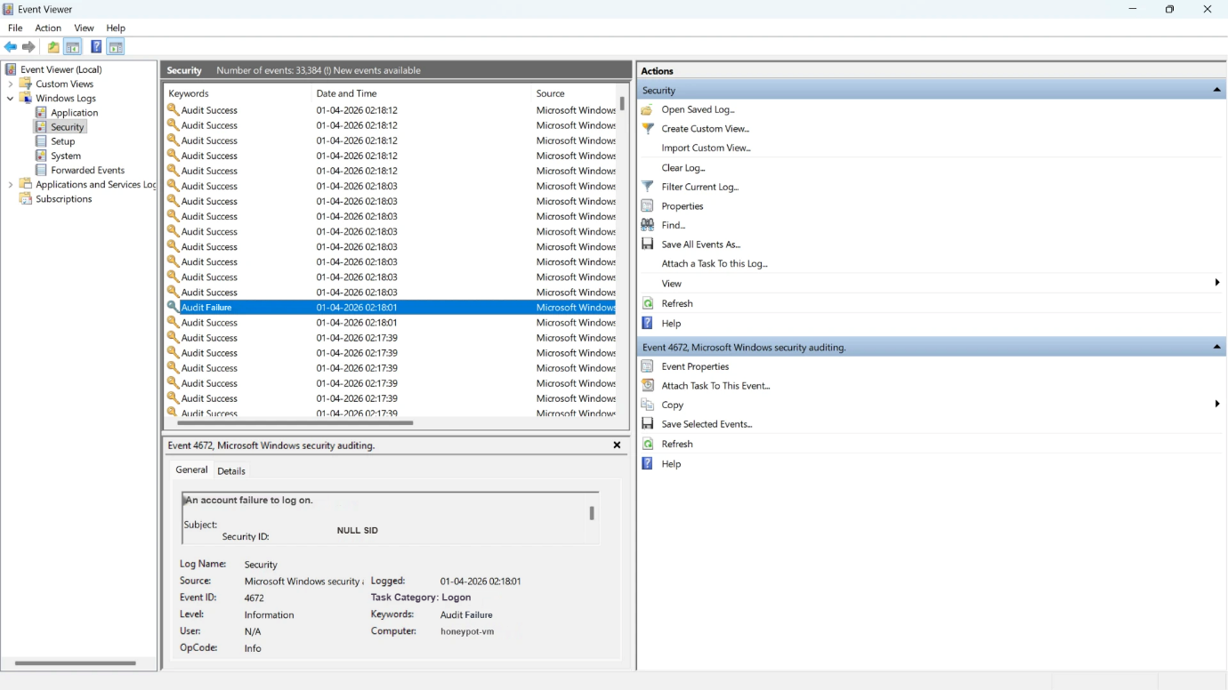Figure 3: Extracted RDP Failed Logon Events (Event ID 4672) from Windows Event Viewer
The frequency and repetition of these events suggest the use of automated tools by attackers attempting to gain unauthorized access.

8.3 Data Enrichment and Processing
To enhance the collected data, a custom PowerShell script was used to extract IP addresses from the logs and enrich them with geolocation information. This process involved sending the extracted IP addresses to an external API, which returned details such as country name, latitude, and longitude.
The enriched data was then stored in a structured format and uploaded as a custom log to the Log Analytics Workspace. This transformation allowed the raw log data to be converted into meaningful and analysable information.

8.4 Analysis of Attack Patterns
The analysis of the collected data was performed using Kusto Query Language (KQL) within Microsoft Azure Sentinel. Queries were used to filter, summarize, and visualize the data, enabling the identification of attack patterns and trends.
The results showed that the honeypot received login attempts from multiple IP addresses distributed across various geographical regions. The geolocation data indicated that many attacks originated from regions commonly associated with high cyber activity. Additionally, the analysis revealed consistent attack patterns over time, highlighting the persistent nature of cyber threats.

8.5 Summary of Data Analysis
Overall, the data collection and analysis process provided valuable insights into real-world cyberattack behaviour. The integration of log data with geolocation information enhanced the depth of analysis and enabled a better understanding of global attack patterns.

9. Results and Findings

9.1 Overview of Observed Results
The implementation of the honeypot-based cybersecurity monitoring system produced significant and insightful results. After deploying the virtual machine and exposing it to the internet, a large volume of unauthorized login attempts was recorded within a short period. These results confirm the effectiveness of the honeypot in attracting real-world cyber threats and demonstrate the prevalence of automated attack mechanisms targeting exposed systems.

9.2 Detection of RDP Brute Force Attacks
One of the key findings of this project was the high frequency of Remote Desktop Protocol (RDP) brute force attacks. The analysis of Windows Event Logs, specifically Event ID 4672, revealed numerous failed login attempts originating from different IP addresses. These attempts were often repeated within short time intervals, indicating the use of automated scripts or bots by attackers.
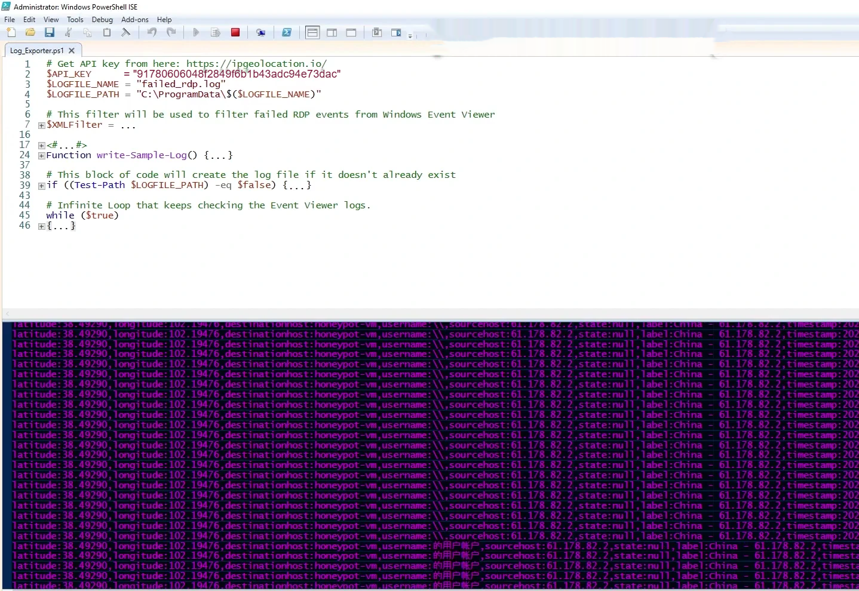Figure 4: Geolocation-Enriched Logs Showing Incoming Attack Sources
The continuous occurrence of such events highlights the vulnerability of systems with exposed RDP ports and emphasizes the importance of monitoring and securing remote access services.

9.3 Geographical Distribution of Attacks
The integration of geolocation data provided valuable insights into the origin of cyberattacks. By enriching the log data with geographical information, it was observed that attacks originated from multiple countries across different regions of the world. Some regions showed a higher concentration of attack attempts, suggesting the presence of active threat sources or compromised networks.

9.4 Visualization of Global Attack Patterns
The use of Microsoft Azure Sentinel enabled the creation of an interactive world map to visualize attack data. The map displayed the geographical distribution of attack sources using latitude and longitude coordinates.

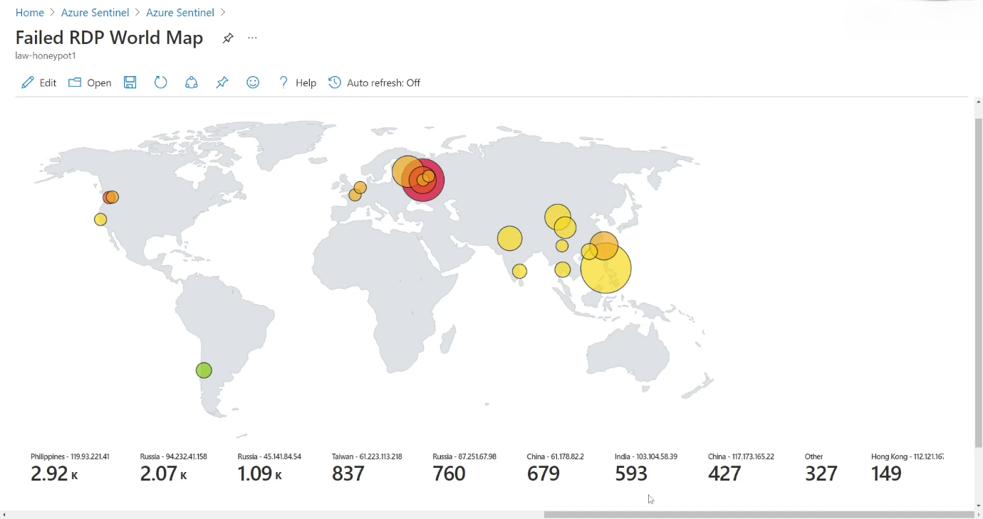Figure 5: Global Attack Distribution Visualized on Azure Sentinel Map
The visualization made it easier to identify patterns and trends, such as regions with high attack density and the spread of attacks over time. This graphical representation enhanced the understanding of global cybersecurity threats.

9.5 Continuous Attack Behaviour
Another important finding was the continuous nature of attack attempts. The system recorded a steady stream of failed login attempts over time, indicating that exposed systems are constantly targeted by attackers. This continuous activity demonstrates the need for real-time monitoring and automated threat detection mechanisms.

9.6 Summary of Findings
Overall, the results confirm that cyberattacks are widespread, persistent, and globally distributed. The project successfully demonstrates how a combination of honeypot techniques and SIEM tools can be used to capture, analyse, and visualize real-world cyber threats effectively.

10. Discussion

10.1 Effectiveness of SIEM-Based Monitoring
The results of this project clearly demonstrate the effectiveness of Security Information and Event Management (SIEM) systems in detecting and analysing cyber threats. By integrating log data from multiple sources into Microsoft Azure Sentinel, the system was able to provide real-time visibility into malicious activities. The ability to collect, correlate, and analyse large volumes of security logs allowed for efficient identification of RDP brute force attacks. This highlights the importance of SIEM solutions in modern cybersecurity operations, particularly in environments exposed to the internet.

10.2 Insights from Geolocation Integration
The integration of geolocation data significantly enhanced the analytical capabilities of the system. By mapping attacker IP addresses to geographical locations, the project provided a clearer understanding of where attacks originated. This additional layer of information made it easier to identify patterns, such as regions with higher attack frequency. The visualization of this data on a global map improved situational awareness and allowed for more intuitive interpretation of complex datasets.

10.3 Analysis of Attack Behaviour
The continuous stream of failed login attempts observed during the experiment indicates that cyberattacks are persistent and often automated. Attackers commonly use scripts or bots to perform brute force attacks, targeting systems with exposed services such as RDP. The findings suggest that even a newly deployed system can quickly become a target once it is accessible over the internet. This emphasizes the need for strong authentication mechanisms and proper security configurations in real-world systems.

10.4 Practical Implications
From a practical perspective, this project demonstrates how cloud-based tools can be effectively used to monitor and analyse cybersecurity threats. It highlights the importance of proactive monitoring, data enrichment, and visualization in improving threat detection capabilities. The approach used in this project can be applied in real organizational environments to strengthen security posture and support informed decision-making.

11. Challenges and Limitations

11.1 API Rate Limitations
One of the primary challenges encountered during the project was the limitation imposed by the geolocation API. The API used for retrieving geographical information of attacker IP addresses had a restricted number of requests per day. This limitation affected the ability to process a large volume of log data continuously. As a result, some IP addresses could not be enriched with geolocation details, potentially reducing the completeness of the analysis.

11.2 Complexity in Log Parsing
Another significant challenge was the complexity involved in parsing raw log data. The logs collected from Windows Event Viewer were unstructured and required careful extraction of relevant fields such as IP addresses, timestamps, and event details. Writing and refining Kusto Query Language (KQL) queries to accurately parse and structure this data was time-consuming and required multiple iterations. Any errors in parsing could lead to incorrect or incomplete analysis.

11.3 Azure Resource Configuration Issues
Configuring Azure resources correctly posed several challenges, especially for initial setup. Issues such as incorrect Network Security Group (NSG) rules, improper linkage between the virtual machine and Log Analytics Workspace, and misconfiguration of Microsoft Azure Sentinel occasionally disrupted data collection and analysis. Troubleshooting these issues required a thorough understanding of Azure services and their interdependencies.

11.4 Time Constraints
Time limitations also impacted the overall scope of the project. The data collection period was restricted to a limited duration, which may not fully represent long-term attack patterns. Additionally, the time required for setup, testing, and debugging reduced the opportunity to implement advanced features such as automated response mechanisms or machine learning-based threat detection.

11.5 Summary of Limitations
Despite these challenges, the project was successfully implemented. However, addressing these limitations in future work would significantly enhance the accuracy, scalability, and effectiveness of the system.

12. Recommendations and Future Work

12.1 Implementation of Automated Response Mechanisms
One of the key recommendations for improving this project is the integration of automated response mechanisms. Currently, the system focuses on detecting and analysing cyber threats; however, it does not actively respond to them. Future implementations can incorporate automated actions such as blocking malicious IP addresses, triggering alerts, or isolating compromised systems. These responses can be achieved by integrating automation tools with Microsoft Azure Sentinel, enabling faster and more effective incident handling.

12.2 Integration of Machine Learning Techniques
Another important area for future enhancement is the use of machine learning algorithms for anomaly detection. By analysing historical log data, machine learning models can identify unusual patterns and predict potential threats more accurately. This would improve the system’s ability to detect sophisticated and previously unknown attacks. Integrating intelligent analytics into the SIEM platform can significantly enhance threat detection capabilities.

12.3 Deployment of Multiple Honeypots
The current project utilizes a single honeypot virtual machine, which limits the scope of data collection. Future work can involve deploying multiple honeypots across different regions and environments. This would allow for a broader analysis of cyberattack patterns and provide more comprehensive insights into global threat behaviour. Multiple honeypots can also simulate different types of systems, attracting a wider range of attack techniques.

12.4 Enhancement of Visualization Dashboards
Improving the visualization dashboards is another important recommendation. While the current system provides a global map of attack locations, additional visual elements such as time-based trends, attack frequency charts, and interactive filters can enhance data interpretation. Advanced dashboards can provide deeper insights and make it easier for security analysts to identify patterns and respond effectively.

12.5 Future Scope
Overall, the future scope of this project lies in expanding its capabilities through automation, intelligent analytics, and improved visualization. These enhancements will transform the system into a more robust and comprehensive cybersecurity solution suitable for real-world applications.

13. Conclusion
This project successfully demonstrates the design and implementation of a real-world cybersecurity monitoring system using Microsoft Azure Sentinel integrated with a honeypot virtual machine. By intentionally exposing the system to the internet, the project was able to capture and analyse genuine cyberattack attempts, particularly Remote Desktop Protocol (RDP) brute force attacks.
The integration of Log Analytics Workspace and custom PowerShell scripting enabled efficient collection, processing, and enrichment of log data. The addition of geolocation information provided deeper insights into the origin of attacks, allowing for a better understanding of global threat patterns. Furthermore, the visualization of attack data on a world map enhanced the interpretability of results and demonstrated the practical value of SIEM tools in cybersecurity operations.
The findings highlight the continuous and widespread nature of cyber threats, emphasizing the need for proactive monitoring and robust security measures. This project not only showcases technical implementation but also reinforces the importance of real-time threat detection and analysis in modern IT environments.
Overall, the project provides a strong foundation for further advancements in cybersecurity monitoring and serves as a practical example of how cloud-based SIEM solutions can be effectively utilized to improve organizational security posture.

14. References
- Microsoft. (2024). Microsoft Sentinel documentation. https://learn.microsoft.com/en-us/azure/sentinel/
- Microsoft. (2024). Azure Log Analytics documentation.
https://learn.microsoft.com/en-us/azure/azure-monitor/logs/log-analytics-overview
- Microsoft. (2024). Azure Virtual Machines documentation.
https://learn.microsoft.com/en-us/azure/virtual-machines/
- National Institute of Standards and Technology. (2020). Guide to Computer Security Log Management (SP 800-92).
https://nvlpubs.nist.gov/nistpubs/Legacy/SP/nistspecialpublication800-92.pdf
- National Institute of Standards and Technology. (2018). Framework for Improving Critical Infrastructure Cybersecurity.
https://www.nist.gov/cyberframework
- SANS Institute. (2021). Intrusion Detection and SIEM Concepts.
https://www.sans.org/white-papers/
- OWASP. (2023). OWASP Top 10 Security Risks.
https://owasp.org/www-project-top-ten/
- Cisco Security: A better way of doing security. (2025, May 2). [Video]. Cisco. https://www.cisco.com/site/in/en/learn/topics/security/what-is-cybersecurity.html
- IBM. (2023). Cost of a Data Breach Report.
https://www.ibm.com/security/data-breach
- GeeksforGeeks. (2025, July 12). What is Honeypot? GeeksforGeeks. https://www.geeksforgeeks.org/blogs/what-is-honeypot/
- Kaspersky. (2023). Brute Force Attacks Explained.
https://www.kaspersky.com/resource-center/definitions/brute-force-attack
- Geolocation.io. (2024). IP Geolocation API Documentation.
https://ipgeolocation.io/documentation/ip-geolocation-api.html
- GeeksforGeeks. (2025b, July 23). What is Cyberwarfare? GeeksforGeeks. https://www.geeksforgeeks.org/computer-networks/what-is-cyberwarfare/
- Scarfone, K., & Mell, P. (2007). Guide to Intrusion Detection and Prevention Systems.
https://nvlpubs.nist.gov/nistpubs/Legacy/SP/nistspecialpublication800-94.pdf
- Kent, K., & Souppaya, M. (2006). Guide to Computer Security Log Management.
https://csrc.nist.gov/publications/detail/sp/800-92/final

